S.VISHNU VARDHAN REDDY(192312244)

Experiment No:2 Implementing TDMA Slot
Allocation in GSM

Objective 1: Matlab Code and Output
clc; clear; close all;
FrameTime = 4.615; Slots = 8;
SlotDuration = FrameTime/Slots;
t = 0:SlotDuration:FrameTime;
figure
subplot(2,1,1)
stem(t,ones(size(t)),'filled')
title('TDMA Time Slot Structure')
xlabel('Time (ms)')
ylabel('Slot Level')
grid on
subplot(2,1,2)
plot(t,ones(size(t)),'-o','LineWidth',1.5)
title('Continuous View of Slot Allocation')

xlabel('Time (ms)')
ylabel('Slot Presence')
grid on

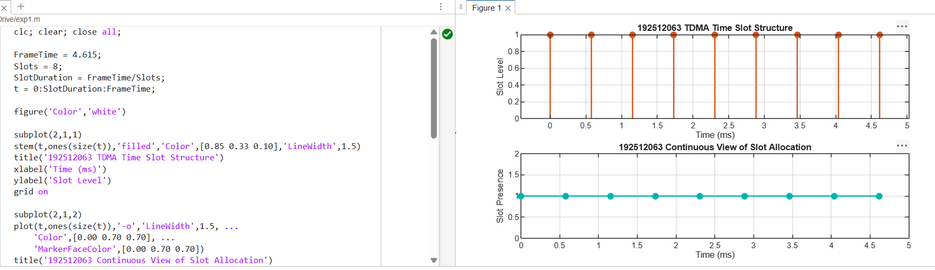
FIG .1.
Objective 2: Matlab Code and Output
clc; clear; close all;
TotalSlots = 8;
AllocatedSlots = 6;
FreeSlots = TotalSlots - AllocatedSlots;
Utilization = (AllocatedSlots/TotalSlots)*100;
disp('Frame Utilization (%)')
disp(Utilization)
figure
% Graph 1: Simple Line Plot (SAFE - no bar function)
subplot(2,1,1)
plot([1 2],[AllocatedSlots FreeSlots],'-o','LineWidth',2)
title('GSM Frame Utilization (Allocated vs Free)')
xlabel('Slot Type Index (1=Allocated, 2=Free)')
ylabel('Number of Slots')
grid on

% Graph 2: Pie Chart (SAFE)
subplot(2,1,2)
pie([AllocatedSlots FreeSlots])
title('Slot Distribution in GSM Frame')
legend('Allocated','Free')
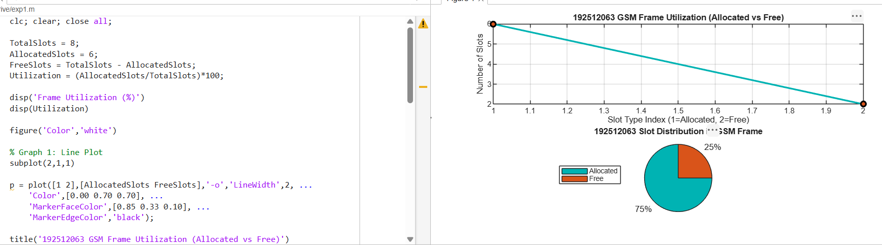
FIG.2.
Objective 3: Matlab Code and Output
clc; clear; close all;
Users = 1:8; % Total users
TotalSlots = 5; % Available slots
Alloc = zeros(1,8); % Initialize allocation
Alloc(1:TotalSlots) = 1; % Assign slots to first users
Blocked = 1 - Alloc; % Remaining users blocked
disp('User Wise Slot Allocation')
disp(table(Users',Alloc','VariableNames',{'User','Status(1=Allocated,0=Blocked)'}))
figure
% Graph 1: Allocation per user
subplot(2,1,1)

stem(Users,Alloc,'filled','LineWidth',2)
title('TDMA Slot Allocation per User')
xlabel('User Index')
ylabel('Slot Status (1=Allocated, 0=Blocked)')
ylim([-0.2 1.2])
grid on
% Graph 2: System view (safe alternative to bar)
subplot(2,1,2)
plot(Users,Alloc,'-o','LineWidth',2)
hold on
plot(Users,Blocked,'-s','LineWidth',2)
title('TDMA Slot Utilization Analysis')
xlabel('User Index')
ylabel('Status')
legend('Allocated','Blocked')
grid on
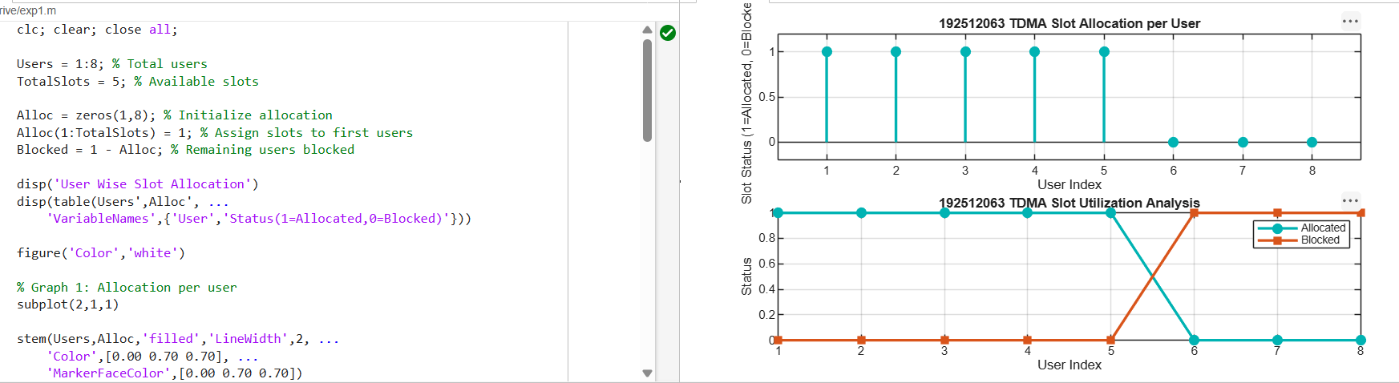
FIG .3.

